Deep Learning-Based Radio Signal Classification

*3 0860814,0860812 M. Farhan Tandia, Ivan Surya H*

***Abstract***

This study investigates the radio signal classification for radio communications signals using Deep Neural Network (DNN). A signal is an observable change in the quantity that carries information. The ability to classify signals is an important task that holds the opportunity for many different applications. In a typical RF setting, a device may need to quickly ascertain the type of signal it is receiving. Previously to classify the signal, we should decompose the signal using FT (Fourier Transform), SIFT, MFCC, or another handcrafting method using statistical modulation features. In the past five years, we have seen rapid disruption occurring based on the improved neural network architectures, algorithms, and optimization techniques collectively known as deep learning (DL). It turns out that state of the art deep learning methods can be applied to the same problem of signal classification and shows excellent results while completely avoiding the need for difficult handcrafted feature selection. In 2017, people use ResNet as a state of the art of computer vision to classify radio communication signals. After three years, computer vision already improved a lot and many methods have become the new state of the art that we could apply for radio signal classification. Hence, we propose a new state of the art method to better classifying radio-signal network.

**I. Background**

Consider the image below: these are just a few of the many possible signals that a machine may need to differentiate.

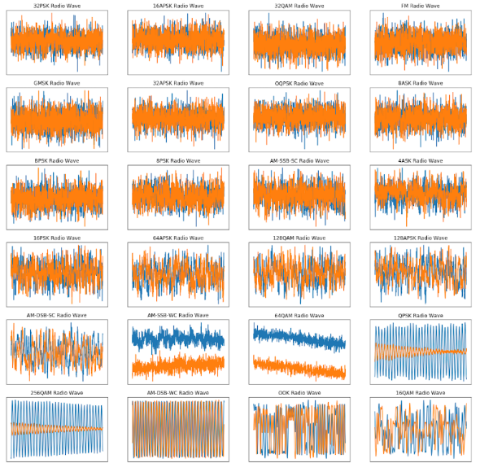

For humans, it is really difficult to differentiate the signal by a look at each signal with our eyes. Hence to classify those signals, humans need to extract some features first. The first method is using statistical modulation features. Using this method, we need to extract the structure of the carrier, symbol timing, and symbol structure for certain modulations and then move the next step of decision criterion using the machine learning method. These methods work well and successfully provide a robust classification for the signal itself. But it still needs a lot of information to classify the signal, hence it will be difficult if the information we got is not completed or one of the information is missing.

The second method is Radio Channel Models, in this method we could modeling wireless based on many compact stochastic models for propagation effect. For example, we could model the carrier frequency offset (CFO), symbol rate offset (SFO), delay spread, and thermal noise. Although it is easier than the first method to make a stochastic model, we still need to create the model of the signal first. We could not input the raw signal directly to our system and get the classification result.

In the past few years, deep learning models have out-paced traditional methods in computer vision that, like the current state of signal classification, involved meticulously creating hand-crafted feature extractors. Deep learning provides a hands-off approach that allows us to automatically learn important features directly off of the raw data.

The deep learning method relies on stochastic gradient descent to optimize large parametric neural network models. At its most simple level, the network learns a function that takes a radio signal as input and spits out a list of classification probabilities as output. The model ends up choosing the signal that has been assigned the largest probability. There is no expert feature extraction or pre-processing performed on the raw data. Instead, the network learns important features on the raw time-series data.

**II. Problem Statement**

1. What is the new state of the art computer vision’s network need to be chosen and suitable for signal classification?
2. How we process the dataset to classify the signal using the new state of the art computer vision network?
3. How we could do a benchmark comparison with the previous state of the art method?

**III. Challenges**



1. In reality, the signal is always not ideal and combined with unwanted signal that is considered as noise. In the image above, we can see how drastically noise can affect our ability to recognize a signal.
2. A clean signal will have a high SNR and a noisy signal will have a low SNR. We should be able to classify signals both in low SNR and high SNR.
3. The classification task will be using the signal under AWGN conditions and Impairments.
4. We use the DeepSig Radio Signal Dataset, this dataset is pretty large (18GB). The state-of-the-art model need around 15 hours to train.

**III. Goal**

* + - * Our target is to get higher accuracy in lower SNR value. It will indicate that our model is robust under the noisy signal modulation.
* We will design a new deep learning architecture and try to get the comparable results in terms of accuracy, model efficiency, training time, and testing time (inference time) with state of the art or even better.

**References**

T. J. O’Shea, T. Roy and T. C. Clancy, "Over-the-Air Deep Learning Based Radio Signal Classification," in IEEE Journal of Selected Topics in Signal Processing, vol. 12, no. 1, pp. 168-179, Feb. 2018, doi: 10.1109/JSTSP.2018.2797022.

A. J. Uppal, M. Hegarty, W. Haftel, P. A. Sallee, H. Brown Cribbs and H. H. Huang, "High-Performance Deep Learning Classification for Radio Signals," 2019 53rd Asilomar Conference on Signals, Systems, and Computers, Pacific Grove, CA, USA, 2019, pp. 1026-1029, doi: 10.1109/IEEECONF44664.2019.9048897.